“I can feel it.”

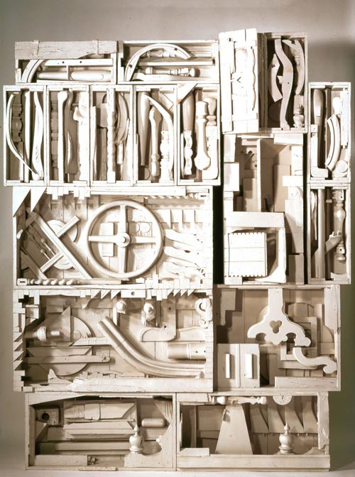
EQ: How can we create artwork to reflect the artwork of Louise Nevelson?

Project: Cardboard Relief Sculpture/ 3D
Untitled Assemble Louise Nevelson

Procedure:
- Get a large piece of cardboard, must be bigger than 9X12.
- Find cardboard pieces and paper towel rolls and arrange on cardboard.
- Also add items from home or found objects.
- Secure all materials down with hot glue.
- When hot glue is secure, take project outside with a scrap sheet of paper or fabric.
- Outside, spray paint the entire project one color.

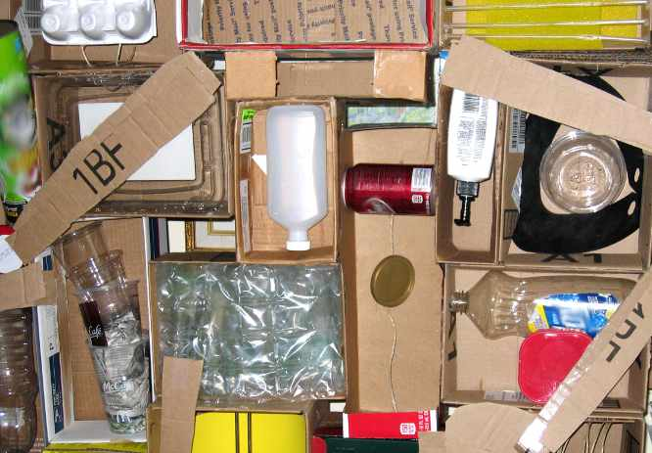
Student Sample before paint:

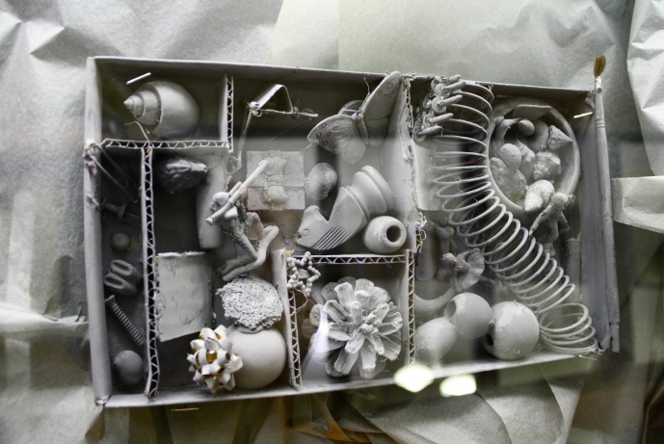
Student Sample after paint:
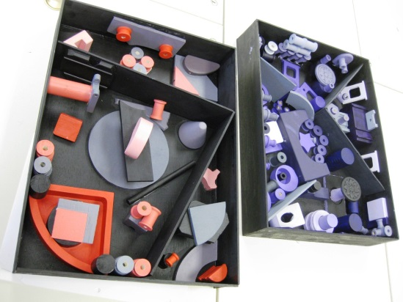
GPS:
VA8PR.3e. Develops three-dimensional artworks from materials such as clay, papier-mache, plaster, wood, wire, found objects and/or combinations of materials.

